**UX AND UI ACTIVITIES-tc2**

## Activity 1: Parkmate Design

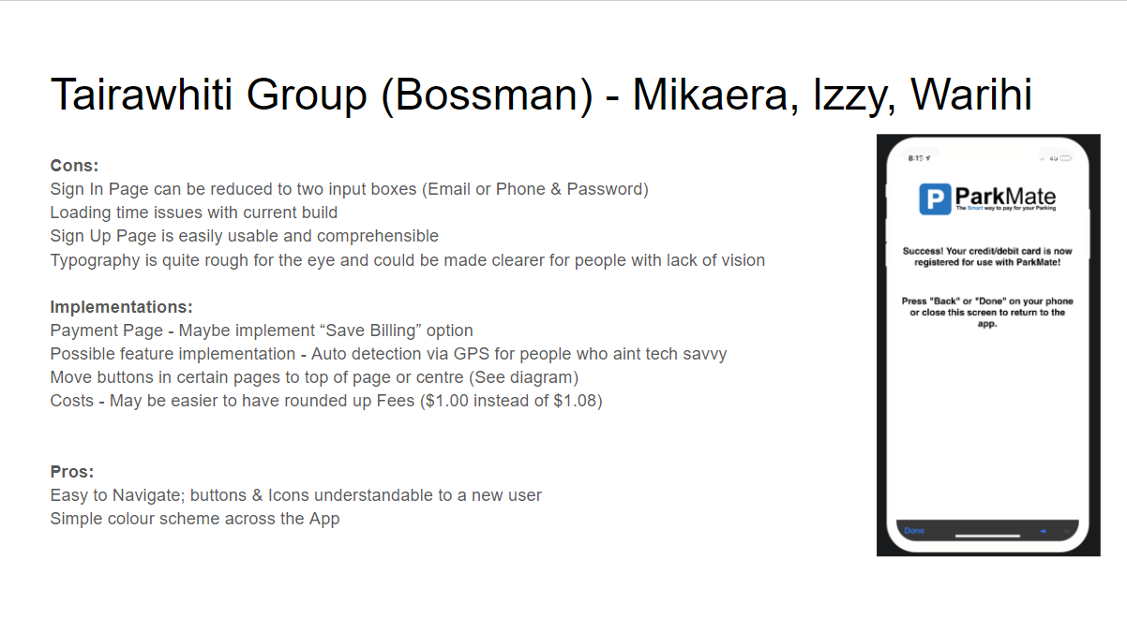

## Activity 2: ASB Mobile vs Desktop

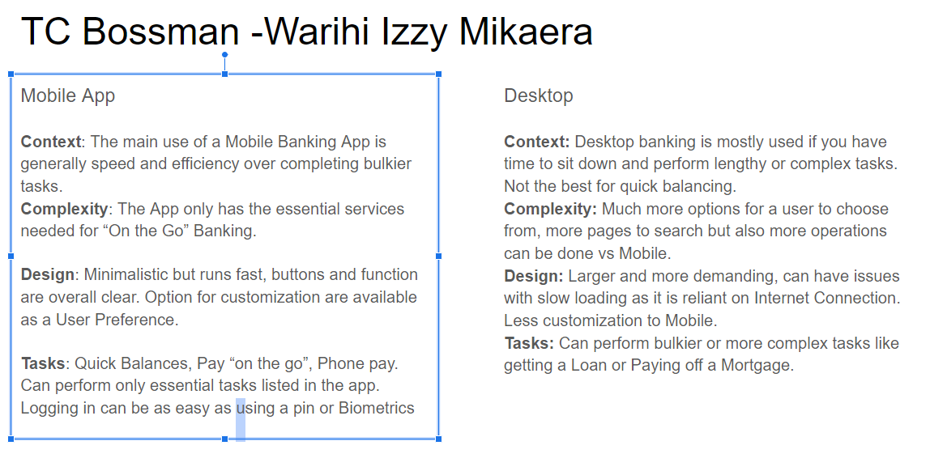

## Activity 3: TradeMe

